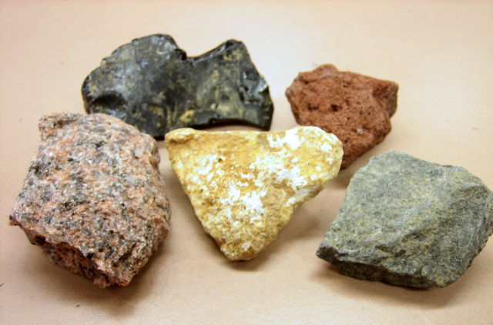

Mineral are pure substances that occur naturally and there are about 3000 known minerals in the earth. Minerals can be found on their own and also mixed together in rocks. A mineral is the same substance all the way through.

Many geologists know what the main minerals look like but often need to classify unusual minerals. Keys are used to identify minerals, including ores and minerals found in igneous rocks.

COLOUR and LUSTRE
- Colour refers to the main colour you can see. Many minerals have a range of colours. Sometimes impurities introduce new colours.
- Lustre is the shininess of the surface. Is it metallic (like a shiny new coin) or is it non-metallic (dull)?

HARDNESS
- Hardness is how readily the mineral is scratched. Does your fingernail scratch the mineral? The Mohs scale measures the degree of hardness of different substances. On the Mohs scale, substances are rated from 1 (very soft) to 10 (very hard).

STREAK and CLEAVAGE
- Streak is the colour of the powdered mineral. You see this when you use the mineral to write on something hard, such as the back of a ceramic tile.
- Cleavage is the ability to break along smooth planes, forming flat layers, sharp corners, boxes or other shapes.

Give the meaning of the following words in the paragraphs above:

1. Pure ________________________________________________________________

2. Naturally _____________________________________________________________

3. Unusual ______________________________________________________________

4. Identify ______________________________________________________________

5. Refers _______________________________________________________________

6. Impurities ____________________________________________________________
7. Metallic ______________________________________________________________

8. Readily _______________________________________________________________

9. Planes ________________________________________________________________
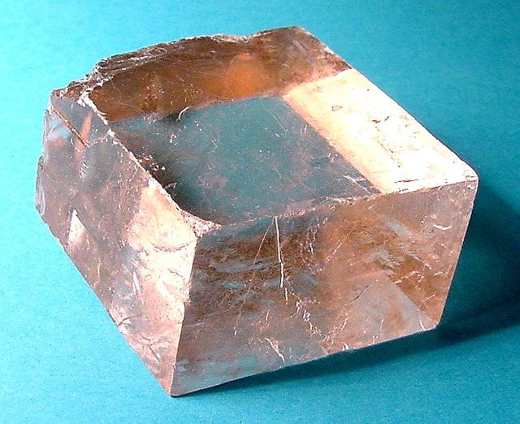

Which words or phrases can be replaced with the following:

1. Materials _____________________________________________________________

2. Identified _____________________________________________________________

3. Combined _____________________________________________________________

4. Sort __________________________________________________________________

5. Name ________________________________________________________________

6. Indicates ______________________________________________________________

7. Variety _______________________________________________________________

8. Easily ________________________________________________________________

9. Scale _________________________________________________________________

10. Crushed _____________________________________________________________

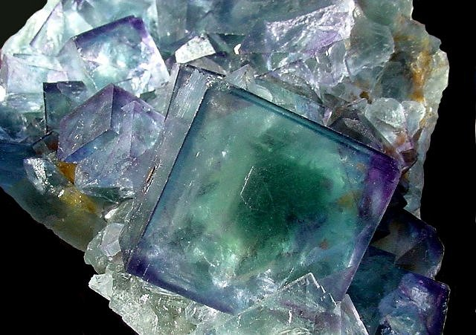
11. Making _____________________________________________________________

Questions

1. What are minerals? __________________________________________________

__________________________________________________________________

2. How many minerals are known on Earth? ________________________________

__________________________________________________________________
3. Describe what minerals are like? _______________________________________

__________________________________________________________________

4. Why might a geologist need a minerals key? ______________________________

__________________________________________________________________

5. What can introduce new colours to a mineral? _____________________________

6. Why are colours not very useful in identifying minerals? _____________________

__________________________________________________________________

7. What is lustre? _____________________________________________________

8. What does non-metallic mean? _________________________________________

9. What does the Mohs scale do? _________________________________________

10. What would a 5 on the Mohs scale be like? _______________________________

__________________________________________________________________

11. What is streak? ______________________________________________________

12. What is the ability to break along smooth planes called? _____________________



